**Guide to set up MongoDB for Helpme team project**

* I overrated our data volume. It seems the 512MB free cloud database is enough for us. However, I still have a brief guide for you to install a local database.
* I have sent a link by email inviting you as an admin of the cloud database.
* Our database has two users now. You can add users once you regester by the above link.
  + Helpme_1   
    password: glasgowcomputer
  + Admin   
    password: glasgowcom

1. Cloud database.

A. Login into our cloud database management web site. You need regester by my inviting Email first  
.  
<https://www.mongodb.com/cloud>

B. Click the button and follow the guide.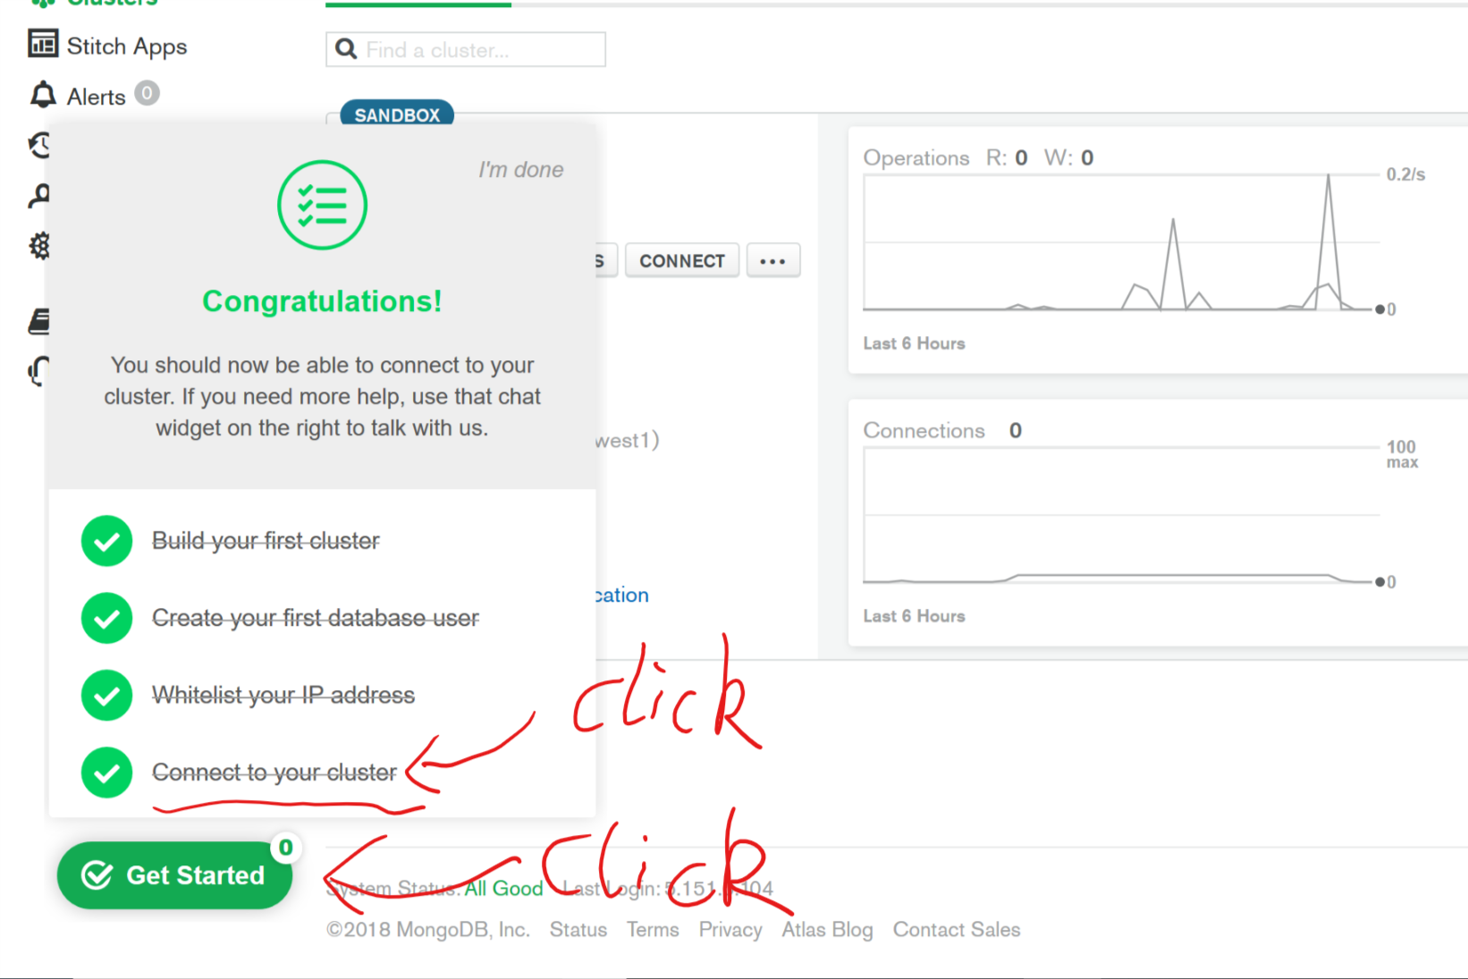

**OR:**

Click these in sequence.

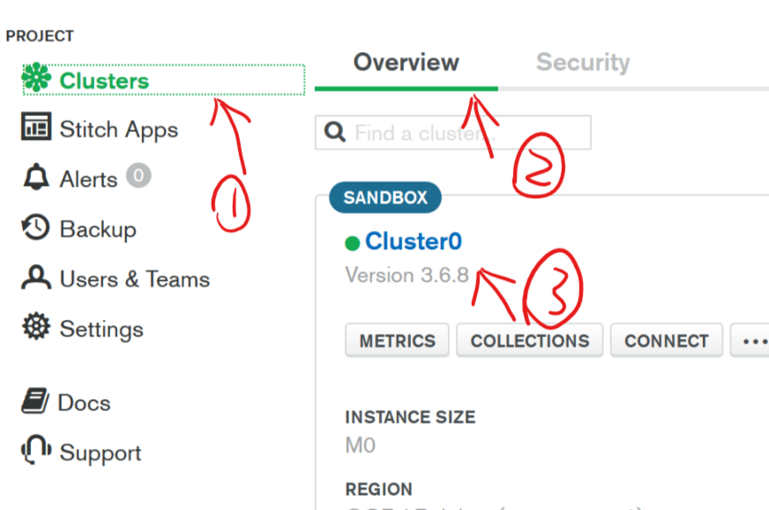

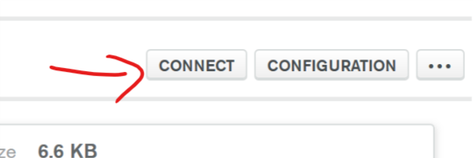

C. Follow the guides.

I recommend you connect with MongoDB Compass first to be familiar with MongoDB.  
You can sue the schema function in MongoDB Compass to check the statistic information about our data.  
2.Local database

Follow the guide: <https://docs.mongodb.com/guides/server/install/>

The brief process is:

1. Install.   
   If you want to change the default data and log directory.   
   remember to upgrade config file.  
   configuration file <install directory>/bin/mongod.cfg

<https://docs.mongodb.com/manual/reference/configuration-options/>

1. Set the data directory. (before run the MongoDB program, you need set a data directory first)
2. Download python client.   
   python -m pip install pymongo
3. Import data:

Install MongoDB Compass and get connected.

Build Three collection:

* “Test”
* “Training”
* “Training_token”

Use the function ,Import data in MongoCompass, to import the .json files uplaoded in **data_files**/. (ignore TRECIS-CTIT-H-Training.json)

3. Some useful tutorials may help you to learn MongoDB.  
  
<https://www.tutorialspoint.com/mongodb/mongodb_analyzing_queries.htm>

<https://university.mongodb.com/>

University

M001: MongoDB Basics. Free